Question 15: AI-Generated Image Using DALL·E
Name: Yuva Ramya | Roll No.: 261FB04014

Prompt Used
Create a realistic and modern smart hospital in a clean and professional environment. Show a large futuristic hospital building with a clear 'CITY CARE HOSPITAL' sign, a medical cross symbol, glass walls, and beautiful landscaping. Include an ambulance at the entrance, doctors, nurses, patients, and visitors. Add a reception area with a nurse, a friendly healthcare service robot, and digital health technology. Show a patient receiving care from a doctor in a modern hospital room with medical monitors. Include a telemedicine screen, advanced diagnostic equipment, robotic surgery technology, digital health records, and 24/7 emergency services. Use a bright blue and white healthcare theme, natural daylight, realistic people, high-quality architectural details, cinematic lighting, photorealistic style, and 4K resolution.
Generated Image (DALL·E Output)
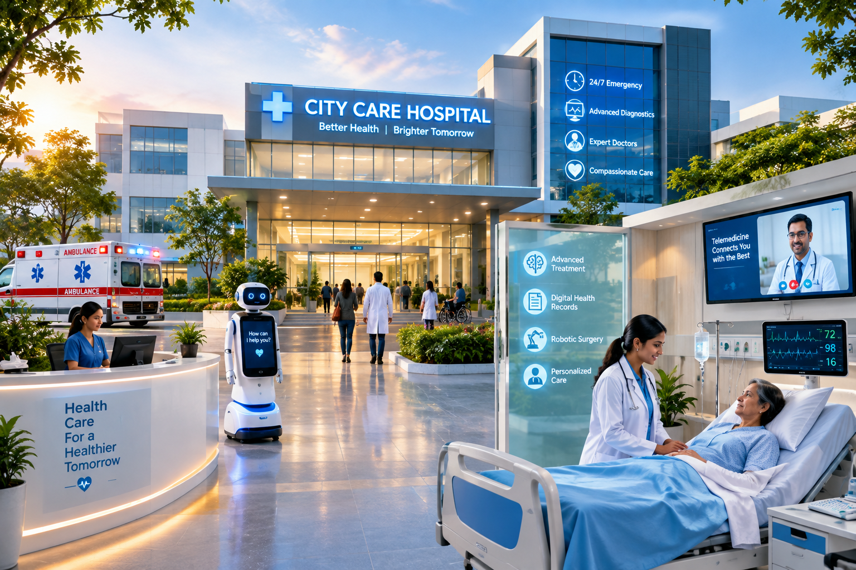
Figure 1: AI-generated modern smart hospital
Result
The image was generated using an AI image-generation tool based on the given text prompt. It represents a modern smart hospital with healthcare professionals, patients, emergency services, digital technology, and advanced medical facilities.

